fClick on File 🡪 New🡪 Maven Project

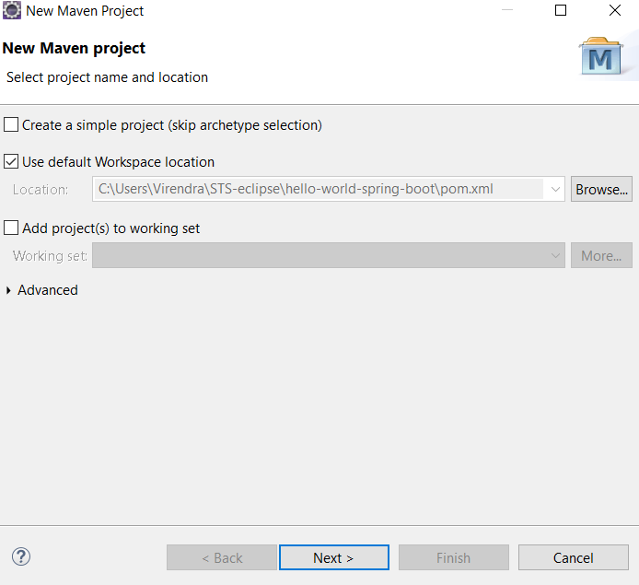  
  
From the **archetype** list,   
Enter in Filter🡪  **maven-archetype-webapp** 🡪 Select below arrow 🡪 click on **Next**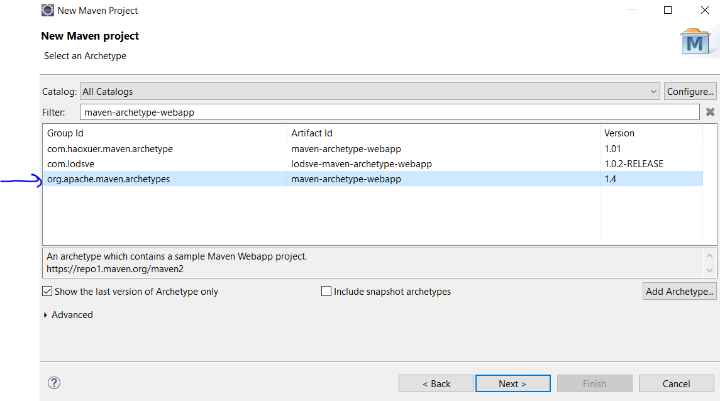

Enter Group Id🡪 **com**

Artifact Id🡪 **SpringSetup (whatever name of the project)** 🡪 click on **Finish**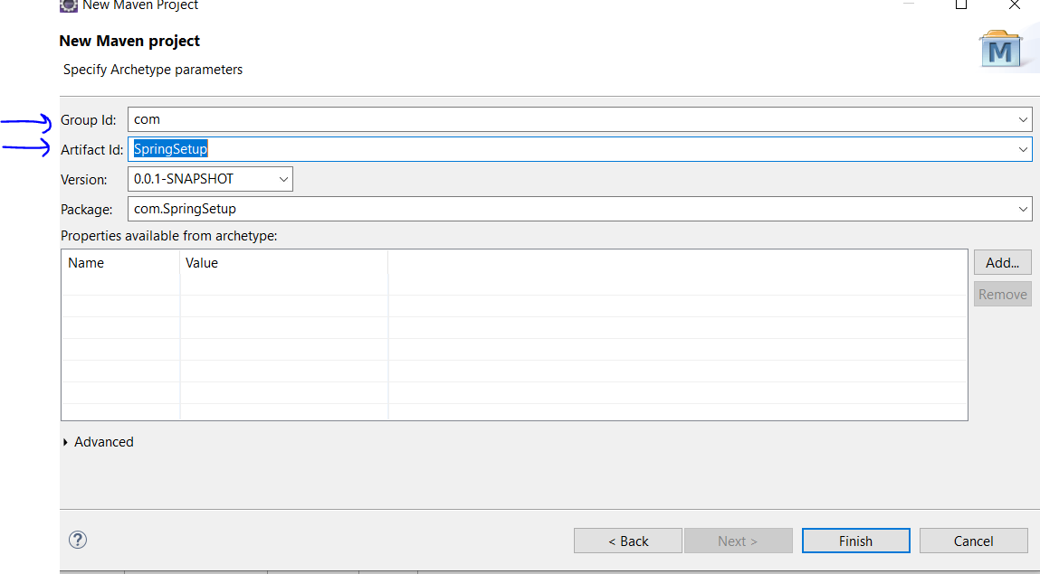

In project explorer it will be below:  
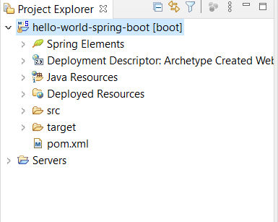  
  
**Open pom.xml file and enter below:**

<java.version>1.8</java.version>

</properties>

<build><project xmlns=*"http://maven.apache.org/POM/4.0.0"* xmlns:xsi=*"http://www.w3.org/2001/XMLSchema-instance"*

xsi:schemaLocation=*"http://maven.apache.org/POM/4.0.0 http://maven.apache.org/xsd/maven-4.0.0.xsd"*>

<modelVersion>4.0.0</modelVersion>

<groupId>com.javadevelopersguide.www</groupId>

<artifactId>hello-world-spring-boot</artifactId>

<version>0.0.1-SNAPSHOT</version>

<description>This is a hello world example with Spring Boot.</description>

<parent>

<groupId>org.springframework.boot</groupId>

<artifactId>spring-boot-starter-parent</artifactId>

<version>1.5.10.RELEASE</version>

</parent>

<dependencies>

<dependency>

<groupId>org.springframework.boot</groupId>

<artifactId>spring-boot-starter-web</artifactId>

</dependency>

</dependencies>

<properties>

<plugins>

<plugin>

<groupId>org.springframework.boot</groupId>

<artifactId>spring-boot-maven-plugin</artifactId>

</plugin>

</plugins>

</build>

</project>  
  
**Right Click on Project 🡪 Maven 🡪 Update Project. Then set JDK 1.8 in build path as shown below**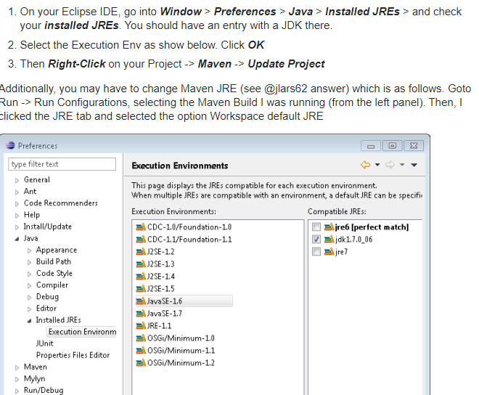

Right Click on Project 🡪 Build Path 🡪 Configure Build Path 🡪 Add Library 🡪 JRE System Library 🡪 Select JDK 1.8  
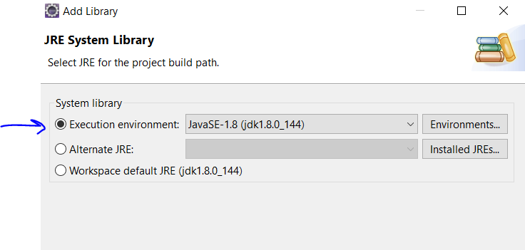

Click Finish (below entry will be made) 🡪 Click “Apply and Close”

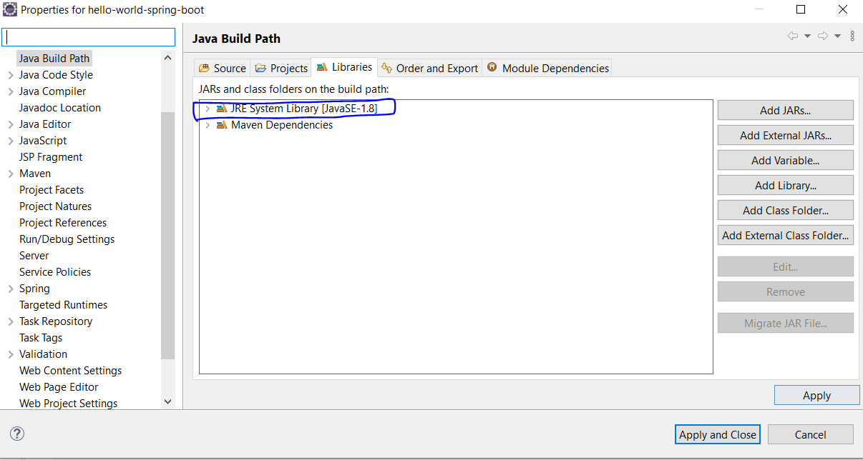  
  
Check first the java project has which JDK version we added above  
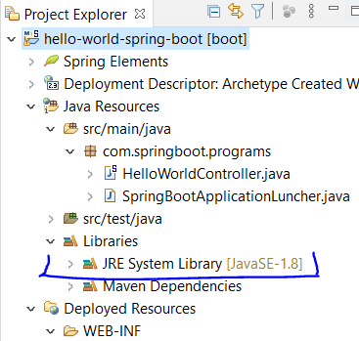

Then change the java version as below from java 1.7 to java 1.8 . **Right click project 🡪 properties 🡪 Project Facets**   
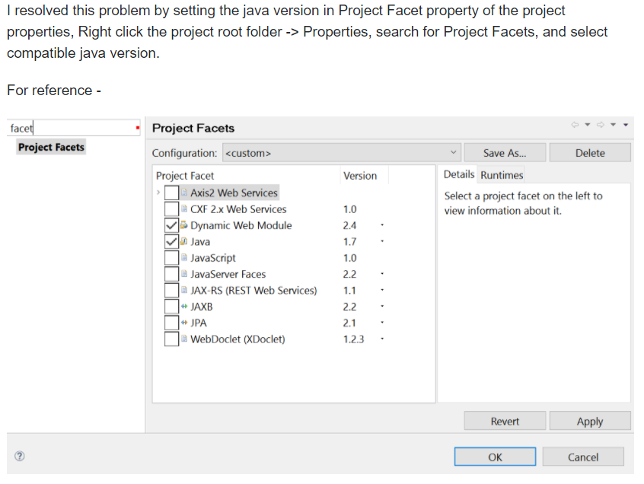

**Create a main java file:**  
**Right click** on the src/main/java (under Java resources) 🡪 create java package   
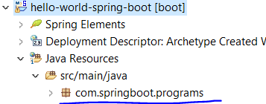  
  
**Right click** on the java package 🡪 Java class(main) 🡪 SpringBootApplicationLuncher.java

**import** org.springframework.boot.SpringApplication;

/**

* This Luncher for the spring boot application.

*/

**public** **class** SpringBootApplicationLuncher {

**public** **static** **void** main(String[] args) {

SpringApplication.*run*(HelloWorldController.**class**, args);

}

}

**Right click** on the java package 🡪 Java class 🡪 HelloWorldController.java  
  
**import** org.springframework.boot.autoconfigure.EnableAutoConfiguration;

**import** org.springframework.stereotype.Controller;

**import** org.springframework.web.bind.annotation.RequestMapping;

**import** org.springframework.web.bind.annotation.ResponseBody;

@Controller

@EnableAutoConfiguration

**public** **class** HelloWorldController {

@RequestMapping("/hello")

@ResponseBody

**public** String sayHello() {

**return** "Hello World Developer!!!";

}

}

**Steps to run the Spring Boot application:**  
1. Right click on project -🡪 Maven -🡪 Update project.  
2. Right click on pom file🡪 Run as 🡪 maven clean-🡪 maven install   
3. Right click on the SpringBootApplicationLuncher.java (class containing the main method) 🡪 Run as ”Java Application”  
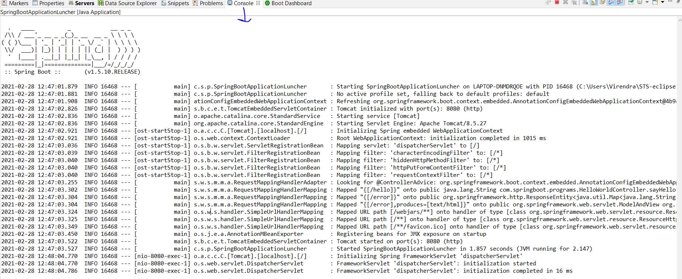  
4. Open chrome and type🡪 <http://localhost:8080/hello> (type welcome as page name in request mapping inside the controller class)